

Condition Assessment Report
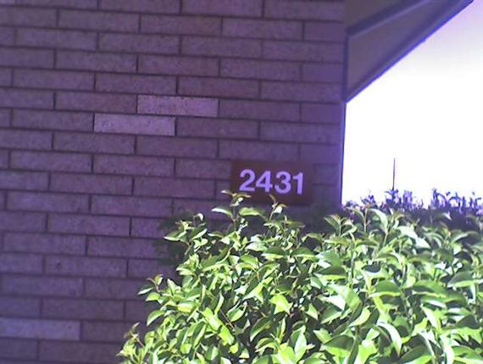
02431-BOWLING ALLEY
N. Beale Rd.
Beale AFB, CA 95901
Inspection Date: | Thursday, June 15, 2017

Building & Job Summary
Building Name | 02431-BOWLING ALLEY
Building Address | N. Beale Rd.  Beale AFB, CA 95901
Year Built | 1961
Roof Area (total) | 17,685 SF
Building Description | 02431-BOWLING ALLEY  Building Type: Institutional/Government  Building Zone: Institutional  Roof Access: Bring Ladder  Floors: Single
Inspection Date | Thursday, June 15, 2017
Inspector | Beale AFB  Clark Peterson  clark.peterson.2@us.af.mil  (P) 530-392-2431
Inspection Notes | W/O # 1681104  Recoat roof with Armorgarage
Building Contact
Client Contact

Section Key Plan
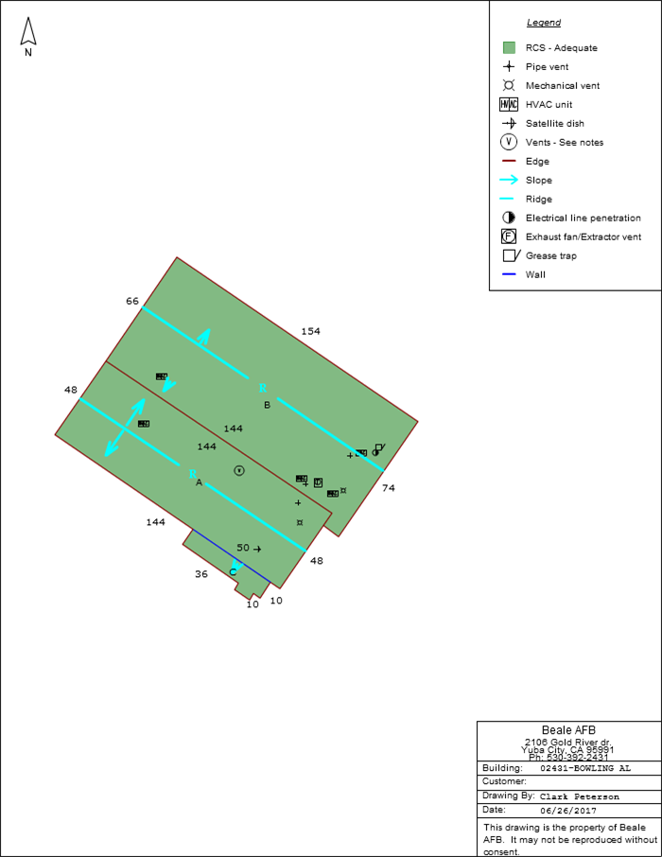

Photo Album
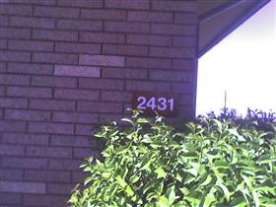  Building Photo | 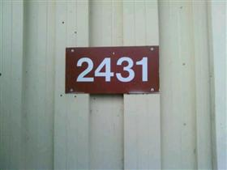  Building Photo
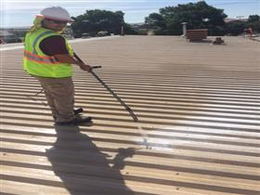  Inspection/Job Photo: soaping down | 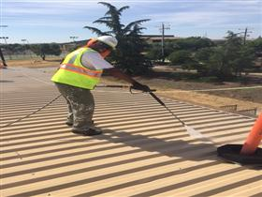  Inspection/Job Photo: preasure washing
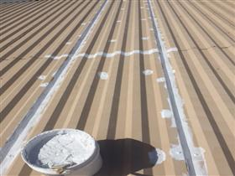  Inspection/Job Photo: seaming with armorgarage | 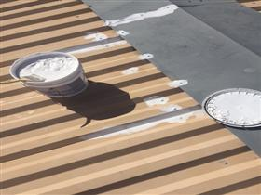  Inspection/Job Photo: seaming with armorgarage
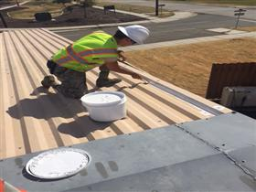  Inspection/Job Photo: seaming with armorgarage | 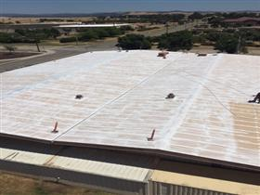  Inspection/Job Photo: priming with armorgarage
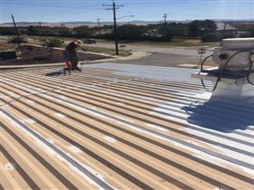  Inspection/Job Photo: priming with armorgarage | 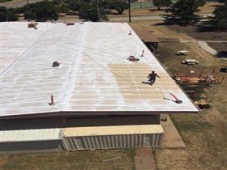  Inspection/Job Photo: priming with armorgarage
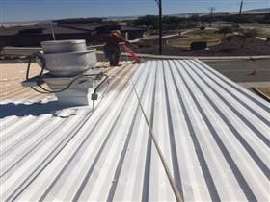  Inspection/Job Photo: priming with armorgarage | 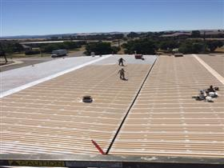  Inspection/Job Photo: priming with armorgarage
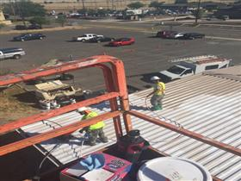
Inspection/Job Photo: base coat armargarage
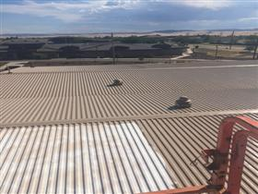  Inspection/Job Photo: base coat armorgarage | 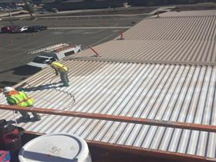  Inspection/Job Photo: base coat with armorgarage
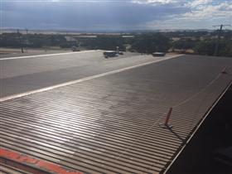  Inspection/Job Photo: basecoat complete armorgarage | 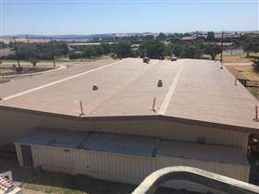  Inspection/Job Photo: base coat complete armorgarage
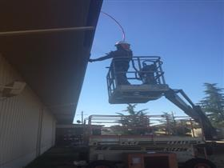  Inspection/Job Photo: coating facia with armorgarage | 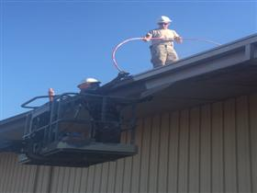  Inspection/Job Photo: coating facia with armorgarage
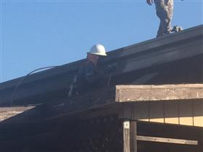  Inspection/Job Photo: coating facia with armorgarage | 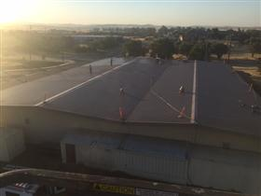  Inspection/Job Photo: 2nd coat armorgarage
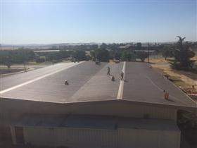  Inspection/Job Photo: 2nd coat armorgarage | 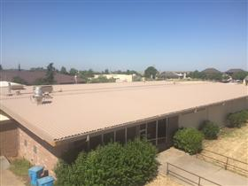  Inspection/Job Photo: roof complete 6/22/2017
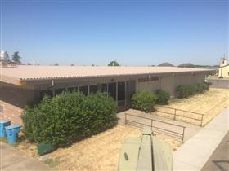  Inspection/Job Photo: roof complete 6/22/2017 | 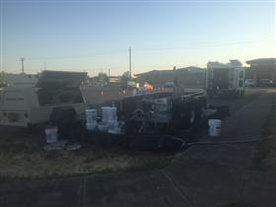  Inspection/Job Photo: ground ops for armorgarage
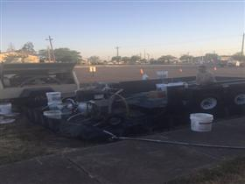
Inspection/Job Photo: groundops for armorgarage

