

Condition Assessment Report
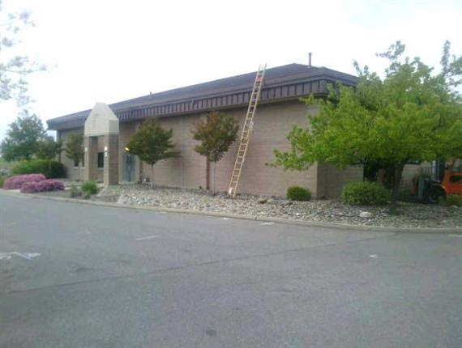
25474-SECURITY FORCES
N. Beale Rd.
Beale AFB, CA 95901
Inspection Date: | Monday, June 26, 2017

Building & Job Summary
Building Name | 25474-SECURITY FORCES
Building Address | N. Beale Rd.  Beale AFB, CA 95901
Year Built | 1996
Roof Area (total) | 5,919 SF
Building Description | 25474-SECURITY FORCES  Building Type: Institutional/Government  Building Zone: Institutional
Inspection Date | Monday, June 26, 2017
Inspector | Beale AFB  Clark Peterson  clark.peterson.2@us.af.mil  (P) 530-392-2431
Inspection Notes | Needs recoat... WO# 2576977  Recoated with armorgarage 8/16/2017
Building Contact | Notes: nicolas.peterson.1@us.af.mil  danielle.yared@us.af.mil  raymond.rocheleau@us.af.mil
Client Contact

Section Key Plan
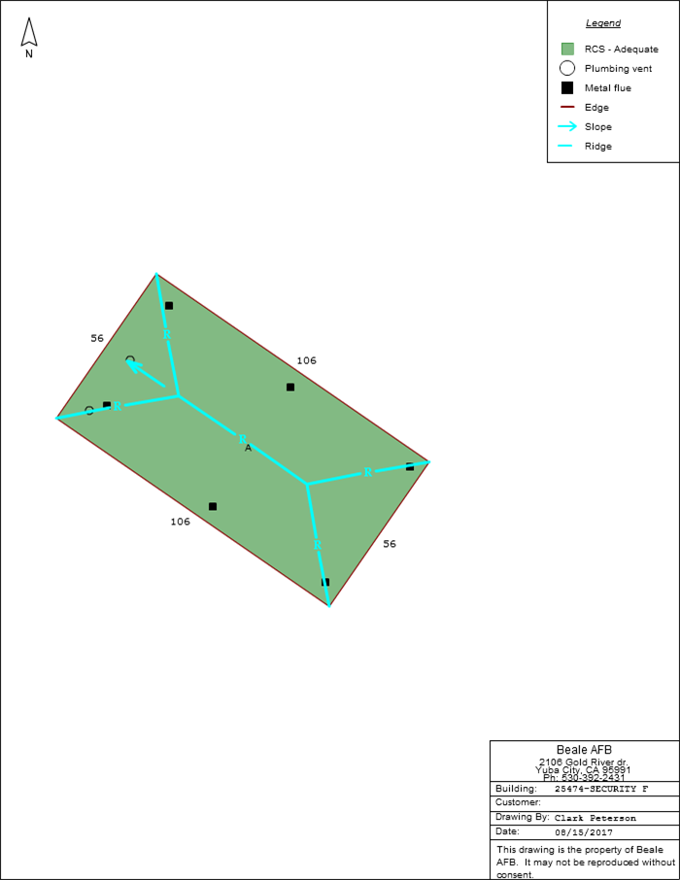

Section Information
Section ID: A
Area: 5,919 SF
Roof Type: Metal
Layers:
● Metal surface:
○ Material: Steel
○ Type: Structural panel
○ Profile: Standing seam
○ Color: Brown
Roof Condition Score: 100 (Adequate)

Roof Condition Scores
 | Section |  | Score
 | A (Area = 5,919 SF) |  | 100 - Adequate
Legend
 |  | Adequate ( 100% )
 |  | Degraded ( 0% )
 |  | Unsatisfactory ( 0% )
 |  | Unspecified ( 0% )

Section A
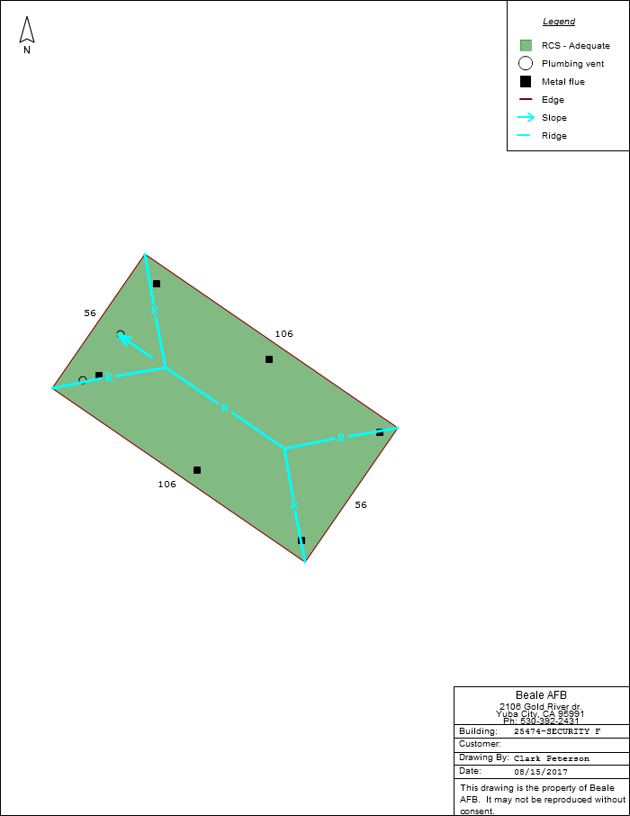

Section Summary – A

Section ID: A
Area: 5,919 SF
Year Installed: 2002 (approximate)
Height: 20 FT
Floors: 0
Sensitivity: High
Roof Condition Score: 100 (Adequate)
Roof Type: Metal
Layers:
● Metal surface:
○ Material: Steel
○ Type: Structural panel
○ Profile: Standing seam
○ Color: Brown

Notes: Prior RCS=55; prior ERSL React/Proact=15/1. Prior RCS=55; prior ERSL React/Proact=15/1.

Inventory Detail – Section A
Segment
● Type: Edge
Drip edge
● Gutter: Yes
Metal flue
● Diameter: 4"
● Flashing: Pipe jack
Metal flue
● Diameter: 4"
● Flashing: Pipe jack
Metal flue
● Diameter: 4"
● Flashing: Pipe jack
Metal flue
● Diameter: 4"
● Flashing: Pipe jack
Metal flue
● Diameter: 4"
● Flashing: Pipe jack
Metal flue
● Diameter: 4"
● Flashing: Pipe jack
Plumbing vent
● Size: 3"
● Material: Cast iron
● Flashing: Rubber boot
Plumbing vent
● Size: 2"
● Material: Cast iron
● Flashing: Rubber boot

Roof Condition Score – Section A
# | Question (Max Value) / Notes | Score
1 | Roof is less than 5 years old and in excellent condition - no observed deficiencies (0)
2 | Are there roof leaks? (5)
3 | Have the past roof leaks caused significant interior damage? (10)
4 | Have roof leaks caused significant damage to building's structural integrity? (10)
5 | Has the roof been leaking for over 1 year? (7)
6 | Does the roof leak every time it rains in 3 or fewer places? (5)
7 | Does the roof leak every time it rains in 4 or more places? (10)
8 | Is the surface of the roofing deteriorated excessively? (4)
9 | Is there excessive patching on the roof? (8)
10 | Is roof-top equipment mounted improperly? (5)
11 | Is roof installation workmanship of medium quality? (3)
12 | Is roof installation workmanship of poor quality? (5)
13 | Remaining roof life > 75% (5)
14 | Remaining roof life 50% - 74% (10)
15 | Remaining roof life 25% - 49% (20)
16 | Remaining roof life <25% (30)
17 | Does the flashing look deteriorated and appear to be letting the water enter the building in a few places? (6)
18 | Does the flashing look deteriorated and appear to be letting the water enter the building in an excessive number of places? (10)
19 | Is exposed sealant showing signs of moderate deterioration? (3)
20 | Is exposed sealant showing signs of excessive deterioration? (5)
21 | Is there a moderate number of metal coating defects? (3)
22 | Is there an excessive number of metal coating defects? (5)
23 | Is there a moderate number of loose or missing fasteners? (3)
24 | Is there an excessive number of loose or missing fasteners? (5)
25 | Is there a moderate number of end lap defects (eave termination/transverse joints)? (3)
26 | Is there an excessive number of end lap defects (eave termination/transverse joints)? (5)
27 | Are the joints in the metal open to let water enter? (2)
28 | Is sheet metal loose and or missing? (3)
29 | Miscellaneous and other conditions - Low (5)
30 | Miscellaneous and other conditions - Medium (10)
31 | Miscellaneous and other conditions - High (15)
32 | Roof is at the end of its life - Immediate Action Required! (0)
 | Total | 0
 | FINAL SCORE (100 – Total) | 100
 | ROOF CONDITION SCORE: Adequate

Photo Album
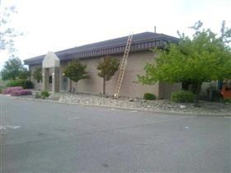  Building Photo | 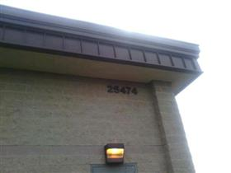  Building Photo
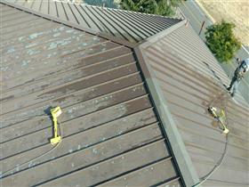  Inspection/Job Photo: Preasure washing 1 | 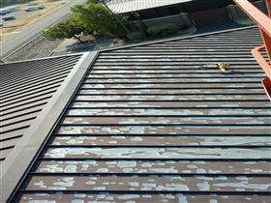  Inspection/Job Photo: Preasure washing 2
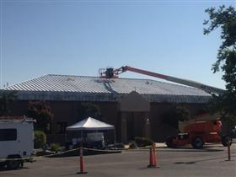  Inspection/Job Photo: Primmer | 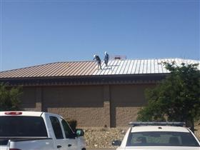  Inspection/Job Photo: Base coat 1
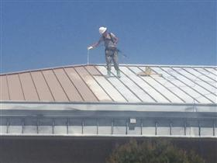  Inspection/Job Photo: Base coat 2 | 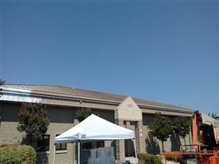  Inspection/Job Photo: Base coat 3
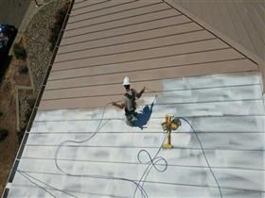  Inspection/Job Photo: Base coat 4 | 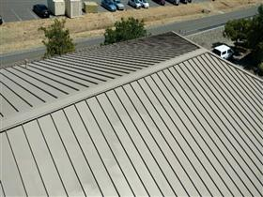  Inspection/Job Photo: top coat 1
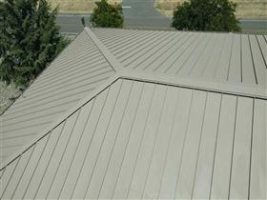  Inspection/Job Photo: top coat 2 | 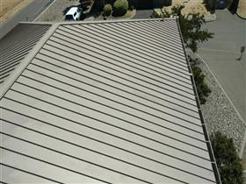  Inspection/Job Photo: top coat 3
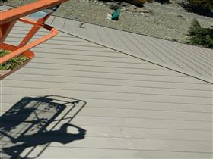  Inspection/Job Photo: top coat 4 | 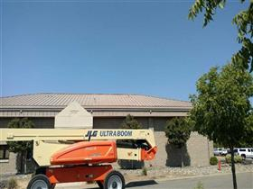  Inspection/Job Photo: complete

